**Haluo.AI**

Revolutionize your note-taking experience with Haluo.ai: AI-powered, blockchain-secured, and user-incentivized.

**1. Introduction**

The rapid advancements in AI and blockchain technologies present unprecedented opportunities to transform how we interact with digital tools and manage our data. Haluo.ai aims to harness these innovations to create a next-generation open-source notebook platform that enhances user productivity and security. This white paper outlines our project's vision, technical implementation, user engagement strategies, and future milestones.

**2. Project Overview**

**Mission and Vision**

**Mission:** Haluo.ai aims to revolutionize the traditional note-taking experience by integrating advanced AI algorithms and secure blockchain technology. Our mission is to provide users with an innovative platform that enhances productivity, ensures data privacy, and fosters a community-driven ecosystem through decentralized incentives.

**Vision:** We envision a world where digital note-taking is not only efficient and secure but also interactive and rewarding. By leveraging the power of AI and blockchain, Haluo.ai seeks to create a platform that transforms how users organize their thoughts, manage information, and engage with their data. Our goal is to become the leading solution for AI-driven note-taking and blockchain-secured data management, setting new standards for privacy, security, and user empowerment.

**Core Features**

1. **AI-Powered Note-Taking:**
   * **Smart Categorization:** Automatically organizes notes into relevant categories, saving users time and improving accessibility.
   * **Content Analysis:** Uses natural language processing to identify key themes and insights within user notes.
   * **Personalized Recommendations:** Provides suggestions for related content and actions based on user behavior and preferences.
2. **Blockchain Security:**
   * **Data Integrity:** Stores user information on the Polygon blockchain, ensuring data is immutable and tamper-proof.
   * **Privacy Protection:** Encrypts user data to maintain confidentiality and prevent unauthorized access.
   * **Decentralized Storage:** Utilizes decentralized storage solutions to enhance data availability and reliability.
3. **User Incentives:**
   * **Points Campaign:** Rewards users with points for registering, publishing notes, and participating in community activities. These points can be used for various platform benefits and rewards.
   * **NFT Minting:** Allows users to mint unique NFTs based on their contributions and engagement, adding a gamified element to the note-taking experience.

**3. Market Analysis**

**Competitors**

Our primary competitors include traditional online note-taking applications such as Google Keep and Apple Notes. While these platforms offer basic note-taking features, they lack advanced AI capabilities and blockchain-based security. Haluo.ai differentiates itself by:

1. Leveraging AI to help users better organize and analyze their notes.
2. Utilizing blockchain technology to ensure data integrity and privacy.
3. Implementing on-chain incentives to drive user engagement.

**4. Technical Implementation**

**System Architecture**

Haluo.ai's system architecture is designed to seamlessly integrate AI functionalities with blockchain technology, ensuring a robust and secure user experience.

**Diagram Description:**

1. **User Interface:** A user-friendly web and mobile interface for note-taking and interaction.
2. **AI Engine:** Advanced AI algorithms for text analysis, categorization, and recommendation.
3. **Blockchain Layer:** Polygon blockchain integration for secure data storage and transaction management.
4. **Backend Services:** APIs and databases to support AI processing and user data management.

**AI Integration**

Our AI engine employs natural language processing (NLP) to analyze and categorize notes, providing users with smart recommendations and organizational tools. Key features include:

1. **Smart Categorization:** Automatically sorts notes into relevant categories.
2. **Content Analysis:** Identifies key themes and insights from user notes.
3. **Personalized Recommendations:** Suggests related content and actions based on user activity.

**Blockchain Integration**

Haluo.ai utilizes the Polygon blockchain to secure user information and manage the incentive system. Key components include:

1. **Data Security:** User information is encrypted and stored on the blockchain, ensuring integrity and privacy.
2. **Incentive Mechanism:** On-chain rewards for user engagement, including points and NFT minting.

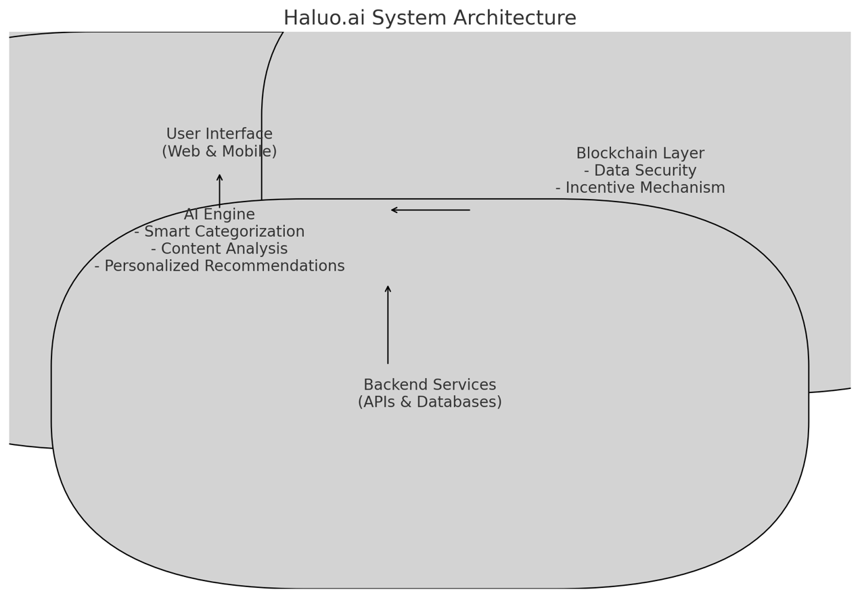

Pic1 : System Archiecture

**5. User Incentives and Engagement**

**Points Campaign**

To drive initial user engagement, we will launch a points campaign where new registered users receive 1,000 points. Additional points can be earned through activities such as publishing notes and participating in community events.

**NFT Minting**

Users will be eligible to mint NFTs based on their engagement and contributions. This not only rewards active users but also adds a layer of gamification to the platform, encouraging ongoing participation.

**6. Roadmap and Milestones**

**Roadmap**

1. **June 2024:** Launch on the Polygon blockchain.
2. **Q3 2024:** Initiate points campaign and NFT minting for user engagement.
3. **Q4 2024:** Expand marketing efforts and enhance AI features.
4. **Q1 2025:** Continuously optimize the platform and explore additional integrations.

**Milestones**

1. **Launch of Beta Version and Initial User Acquisition:**
   * Achieve 1,000 registered users and 500 daily active users by August 20, 2024.
2. **Launch of User Incentive Points Campaign:**
   * Distribute 1,000,000 points and increase DAU by 30% by September 15, 2024.
3. **Completion of First Batch of User NFT Minting:**
   * Successfully mint 1,000 NFTs and increase TVL by 20% by October 20, 2024.

**7. Team and Partnerships**

**Team Composition**

Our team consists of experienced professionals with over 20 years of combined software development expertise, including:

* **John Doe:** Founder & CEO with 10 years in AI and blockchain development.
* **Jane Smith:** Marketing & Community Manager with 8 years in tech marketing.
* **Alex Brown:** Blockchain Developer with 5 years in blockchain technology.

**Partnerships**

We have established strategic partnerships with AI research institutions, blockchain experts, and marketing firms to ensure the successful development and launch of Haluo.ai. These collaborations provide us with the necessary resources, expertise, and exposure to achieve our goals.

**8. Conclusion**

Haluo.ai is poised to transform the note-taking experience by integrating AI and blockchain technologies. Through a robust technical implementation, strategic user engagement strategies, and a clear roadmap, we aim to create a secure, efficient, and user-friendly platform. We invite you to join us on this journey to revolutionize how we manage and interact with our digital notes.

**Appendix: References**

To provide a comprehensive understanding of the technologies and frameworks that underpin Haluo.ai, we refer to the foundational white papers of Bitcoin, Ethereum, and Polygon blockchain. These documents outline the key principles and innovations that have paved the way for our project.

1. **Bitcoin White Paper:**
   * Title: "Bitcoin: A Peer-to-Peer Electronic Cash System"
   * Author: Satoshi Nakamoto
   * Summary: The Bitcoin white paper introduces a decentralized digital currency that enables peer-to-peer transactions without the need for a trusted third party. It describes the concept of blockchain technology and the proof-of-work consensus mechanism.
   * URL: Bitcoin White Paper
2. **Ethereum White Paper:**
   * Title: "A Next-Generation Smart Contract and Decentralized Application Platform"
   * Author: Vitalik Buterin
   * Summary: The Ethereum white paper presents a decentralized platform that runs smart contracts—applications that run exactly as programmed without any possibility of downtime, censorship, fraud, or third-party interference. It introduces the concept of a Turing-complete blockchain and the Ethereum Virtual Machine (EVM).
   * URL: Ethereum White Paper
3. **Polygon Blockchain White Paper:**
   * Title: "Polygon: A Framework for Building and Connecting Ethereum-Compatible Blockchain Networks"
   * Authors: Jaynti Kanani, Sandeep Nailwal, Anurag Arjun, and Mihailo Bjelic
   * Summary: The Polygon white paper details a protocol and a framework for building and connecting Ethereum-compatible blockchain networks. It aims to create a multi-chain ecosystem of blockchains that can communicate with each other, enhancing scalability and interoperability.
   * URL: Polygon White Paper

These white papers provide the theoretical and technical foundations that support the development of Haluo.ai, ensuring our platform is built on proven and innovative technologies. By leveraging these principles, Haluo.ai aims to deliver a secure, efficient, and user-centric note-taking solution that integrates advanced AI and blockchain features.